Memorandum

|  |  |  |  |
| --- | --- | --- | --- |
| Memo No. | 1 | Date of Issue | 17/04/2025 |
| Subject | Scope of Services – Utility Services Equipment | Discipline | Equipment Provision |
| Project Name | Consolidated Maintenance Plan – Yap State | Package No. | 250415001 | |
| Document No. | 250415001-Yap-001 | Revision | 0 (original) | |
| Author | Shankarah Lessey | | | |
| Reviewed by | Patrick Drakes | Approved by |  | |
| Prepared for | Utility Equipment Suppliers | Attention to | Supplier Authorised Representatives | |
| Attachments | n/a | | | |

# Purpose/Introduction

This document is provided as **Appendix A Scope of Services** to the associated **Request for Quotations** (RFQ) document. It is provided to suitably qualified, experienced, and reputable Utilities Equipment Supply firms willing to supply services to the Federal States of Micronesia (FSM) (Suppliers) for purposes of providing a lump-sum (LS) fixed fee quotation to supply specific Utility Equipment and Training on behalf of The Department of Transport, Communication and Infrastructure (DTCI).

The RFQ and this **Scope of Services** relates to the Infrastructure Maintenance Fund financed by the US Compact for Yap State Government to cover expenses related to their Consolidated Maintenance Plan.

# Equipment Supply Requirements

## General

The Service Provider must supply the following **Company Documents** along with its **Form of Quotation**:

1. Occupational Health & Safety (OHS) policy and procedures
2. Proof of Insurances: insurance certificates, clearly stating provider, amount, and validity (dates)
3. Organisational Chart: including identifying those who will be directly involved in providing the requested services

The equipment supply is limited to the equipment specified. However, the individual specifications for the required equipment given in the RfQ are broad and it shall be at the supplier’s discretion as to the make and model identified as being suitable for undertaking the works. Note that the availability of equipment is crucial to the project and the supplier must take cognisance of both the timelines and the size of the project being undertaken and not over specify needlessly.

The procurement process is split into two parts:

Part 1 – procurement of equipment ex-factory and after sales support (including Warranties)

Part 2 – delivery to FSM, commissioning and training

## Part 1 – Procurement ex-factory and after sales support

The following three items of equipment (or combination of these) are required:

### 2024 Peterbilt Model 537 4x4 Chassis Trucks x 2

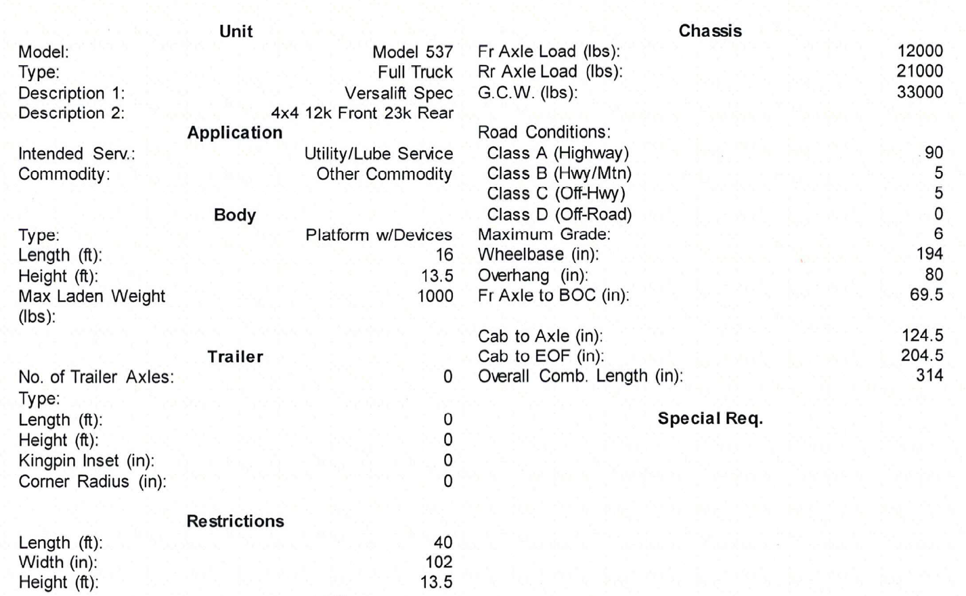

### Versalift TMD2047-T Digger Derrick

The following minimum technical specifications are required:

(See Appendix B)

### Versalift Hydraulic Bucket Lift

The following minimum technical specifications are required:

(See Appendix C)

### Warranty

The above equipment must come with a minimum of 3 years warranty from date of delivery. A detailed breakdown of the after sales service offered as part of the standard sale agreement must be attached.

## Part 2 – Delivery to FSM and Training

FSM is located in the Pacific region, with the equipment required to be delivered to Colonia, Yap. All pricing must be given without any form of taxes or duties. The equipment is to be delivered to Colonia and the cost for this delivery must form part of the quotation but be separate to the equipment costs.

### Delivery to FSM

The delivery must be CIF (cost, insurance and freight):

“*the seller delivers the goods, cleared for export, onboard the vessel at the port of shipment, pays for the transport of the goods to the port of destination, and also obtains and pays for minimum insurance coverage on the goods through their journey to the named port of destination.*

*The buyer assumes all risk once the goods are on board the vessel for the main carriage; however, they don’t take on any costs until the freight arrives at the named port of destination.*”

Incoterm 2020

### Training on Equipment Supplied

All equipment should be accompanied by an expert who is fully familiar with the operation and minor maintenance of the equipment. A price must be given for a technical/operational member from the supplier’s organisation to provide training on the equipment at the manufacturer’s warehouse.

The delivery must include a minimum of:

Inspection and training of appropriate personnel at Manufacturers warehouse

Commissioning and testing of all systems after arrival.

Training on the Operation of all systems to ensure the machinery can be operated safely and effectively.

Training on the basic maintenance of all systems and to ensure correct cleaning and lubrication between services.

Delivery of Spare Parts packages

# Timing of delivery

From contract signing, the Service Provider will have a total of 6-months to dispatch the equipment from warehouse/factory to Yap, Colonia, FSM.

Training and Inspection shall take place no later than 5 months after the signing of the Contract at the manufacturer’s warehouse, provision will be made for flights and per diem travel of two (2) employees from Yap State Government as follows for the inspection, clearance and training of the equipment operations prior to being allowed to ship the equipment:

1. Yap State Utility Employee (End User)
2. Yap State PMO Manager (Inspector)

Provisional sums have been identified in the Supply and Delivery Schedule/Quotation to cover these fees.

Delivery, commissioning and final training shall take place no later than 5 working days from date of arrival of the equipment in FSM.

No work plan documents are required to be provided along with the **Form of Quotation** but shall be provided within 3-working days of any request made by DTCI during the contract.

# Standards of Conduct

These include the following which are linked to the **Form of Contract**.

# Annex A. Supply and Delivery Schedule

|  |  |  |  |  |  |  |
| --- | --- | --- | --- | --- | --- | --- |
| **Item** | **Description** | **Unit** | **Quantity** | **Unit Price (USD)** | **Total Price (USD)** | **Delivery Schedule (months)** |
| **Part 1**  1.1 | **Procurement ex-factory and after sales support**  2024 Peterbilt Model 537 4x4 Chassis |  | 2 |  |  | 6 |
| 1.2 | Versalift TMD2047-T Digger Derrick |  | 1 |  |  | 6 |
| 1.3 | Versalift Hydraulic Bucket Lift |  | 1 |  |  | 6 |
| 1.4 | Spare Parts Package for x 2 Trucks, Digger Derrick and Hydraulic Bucket Lift |  | 4 |  |  | 6 |
| 1.5 | Warranty | Years | 3 |  |  |  |
|  | Sub Total Part 1 |  |  |  | . |  |
| **Part 2** | **Delivery to FSM and Training** |  |  |  |  |  |
| 2.1 | CIF Shipping to Colonia, Yap, FSM | LS | N/A |  | 50,000.00 | *5* |
| 2.2 | Commissioning, systems check and training at manufacturer yard and on site (Colonia, Yap, FSM) | LS | N/A |  | 30,000.00 | 6 |
|  | Sub Total Part 2 |  |  |  | . |  |
|  |  |  |  |  |  |  |
|  | **Grand Total Part 1 and Part 2** |  |  |  | **.** |  |
|  | *(Note: Grand Total to be taken to the Form of Quotation)* |  |  |  |  |  |
|  |  |  |  |  |  |  |

Refer to further notes overleaf

**Part 1 – Procurement ex-factory and after sales support**

Should the supplier offer an all-in-one solution (3-in-1) for these three units as a package (so either one machine or as a package deal with all three units and couplings provided as a single package), then items 1.1, 1.2 and 1.3 should be left blank and item 1.4 filled in. Should the supplier not offer a 3-in-1 solution, then item 1.4 should be left blank.

The name and model of the Unit being offered must be filled in under column titled “Unit”.

A full technical specifications sheet, with equipment item description, shall be submitted as part of the RfQ documents for assessment that aligns with the provided technical specifications;

**Part 2 – Delivery to FSM and Training**

The value quoted must be a lump sum for the transport, Commissioning and training required for all equipment and accessories provided. A detailed schedule of time required for the carrying out of this phase shall be agreed once the procurement order has been given and the time frames for Part 1 have started.

**Total contract amount:**

All pricing is to be quoted in United States Dollars and all exchange control risks shall be carried by the supplier.

A lump-sum (LS) ceiling total contract amount will be established based on the total price reflected in the **Form of Quotation.**

This total contract amount will include all expenses associated with the provision of the services and equipment requested in this RfQ. Provision for travel and accommodation for personnel must be provided for under this amount. No additional fees shall be entertained as part of the delivery of the above equipment or services.

**Taxes and Duties:**

All import duties or taxes arising in FSM shall be for the account of the Client with assistance being given for the importation and movement of equipment in FSM once delivered.

**Payments:**

Payment terms shall be agreed as part of the award process.